**Question 1**

A local tourist attraction is reachable only by small canoes that hold no more than six tourists safely. Tourists are divided into groups of six and the remaining tourists are given a canoe for themselves if they are three or more. If the number remaining is less than three that group will not be able to see the site.

Write a program that will take the number of tourists visiting as input and it calculates the number of canoes needed and print it. If the number of remaining tourists is less than three, print “The remaining tourists will not be able to see this site today”.

**Question 2**

The customs department uses a program to compute the duties and taxes to be paid on used cars imported into the country.

* All cars pay a duty of 40% of the landed value of the car (cost of vehicle plus shipping charges)
* All cars with an engine capacity of 1800 cc and above pay a luxury tax of 10% of the landed value of the car
* Cars with an engine capacity below 1800 cc are not charged any luxury tax.

For each car, the program will compute the customs duties to be paid, luxury tax to be paid and the total duties and taxes.

Required:

* Write a java application to implement the above logic
* All variables should be in one class and the logic should reference from that class( @ classes are needed)

**Question 3**

The pseudocode below inputs two non-zero numbers and a sign, and then performs the calculation shown by the sign. An input of zero for the first number terminates the process.

INPUT Number1, Number2, Sign

WHILE Number1 < > 0

IF Sign =’+’ THEN Answer = Number1+ Number2 ENDIF

IF Sign =’-’ THEN Answer = Number1- Number2 ENDIF

IF Sign =’*’ THEN Answer = Number1* Number2 ENDIF

IF Sign =’/’ THEN Answer = Number1/ Number2 ENDIF

IF Sign < > ‘/ ’ AND Sign < > ‘ * ‘ AND Sign < > ‘ - ‘ AND Sign < > ‘ + ‘

THEN Answer = 0

IF Answer < > 0 THEN OUTPUT Answer ENDIF

INPUT Number1, Number2, Sign

ENDWHILE

**Question 4**

In Country C, on a small, man-made island, the life expectancy (LE) for a male child at birth is 20 years more than half the age of the father. The life expectancy (LE) for a female child at birth is 30 years more than one-third the age of her father.

Required

* Write a java program to compute the life expectancy of the male or female of that country basing on the
  + Gender input by the user
  + Age of the father as input by the user
* Your program should only exit if the user types the age as 200

**Question 5**

Write a java code to perform the following

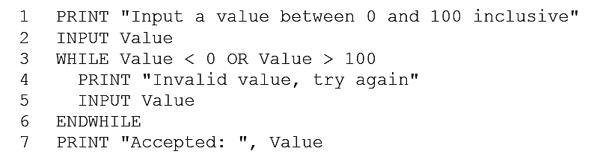

**Question 6**

Consider the following method of calculating a discount on purchases:

Customers will be given a 3% discount on all purchases up to the first $100.00 spent at the store and a further discount of 5% if the amount is greater than $100.00.

Write a java program that accepts the customer number and value of the total purchases, calculates the discount and print on three different lines, the Purchase total, the Discount and the final Cost (Purchase Total – Discount). Also print on one line, the customer number and Final cost,

**Question 7**

A tiny Island has taken strict measures to ensure that pollution from a chemical plant does not adversely affect its citizens. Officials determine that the following fines will be applied to this plant

|  |  |  |  |
| --- | --- | --- | --- |
|  | Pollution level (%) | Status | Fine |
| 1 | 0 – 25 | Acceptable | None |
| 2 | 26 – 50 | Unsatisfactory | $10,000 |
| 3 | >50 | Hazardous | $25,000 |

When pollution rises above 50%, the Island will shut down the plant for 3 months while charges are made. If the plant is closed, the company loses profits totaling to $375,000

Write a program that will determine the total expenses (fines and profits lost) that the company will suffer in the event that pollution rises above the permitted level.